**NESTED AND COMPLEX QUERIES**

**Retrieve unique LeagueIDs from LEAGUE that also exist in LEAGUESTANDING**:

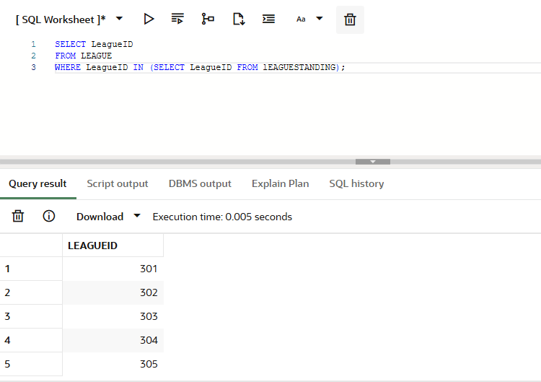

**Find teams that have no match residing in them:**

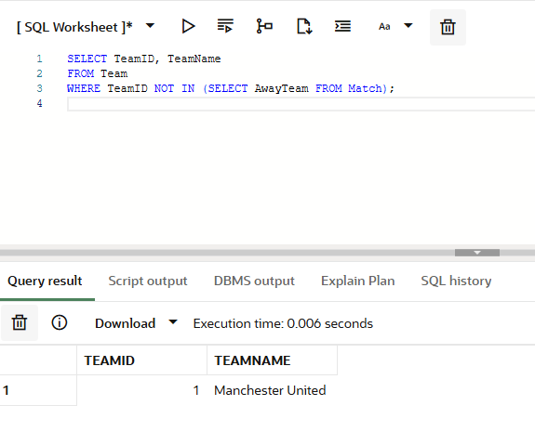

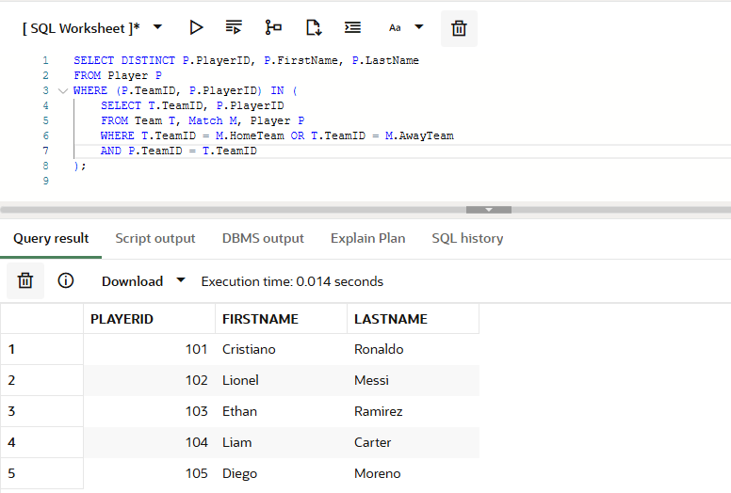

**Retrieve the PlayerID, FirstName, and LastName of players who are older than at least one player whose position is Forward.**

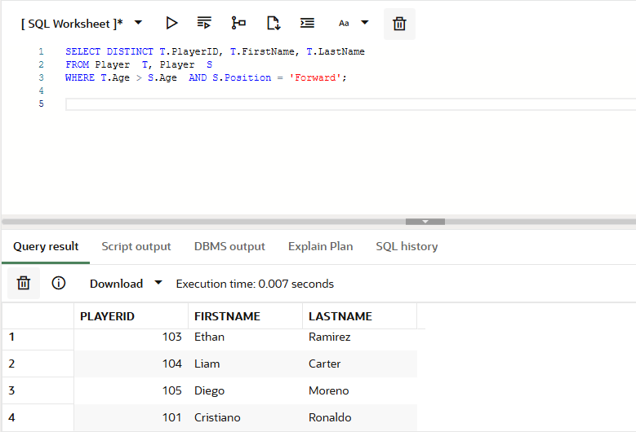

**Retrieve the LeagueIDs of leagues where the LeagueName is greater than at least one LeagueName from leagues in Spain.**

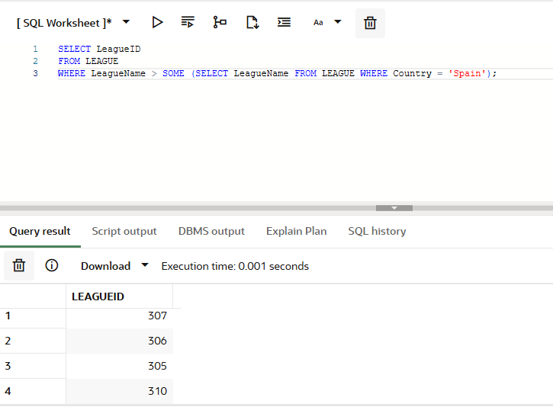

**Retrieve PlayerID of players that have a greater age than players containing Forward:**

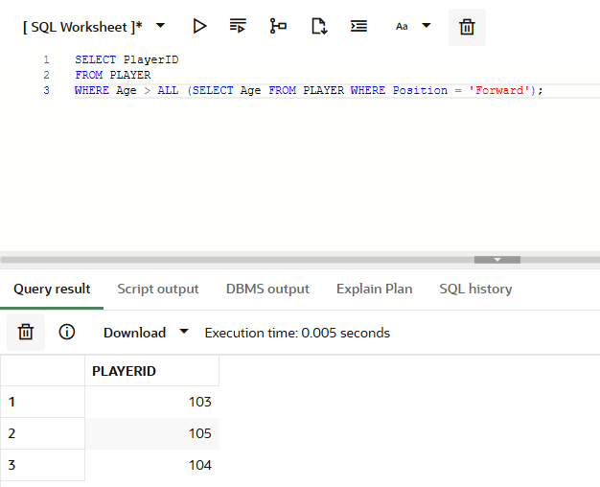

**Retrieve teams that all player have there age:**

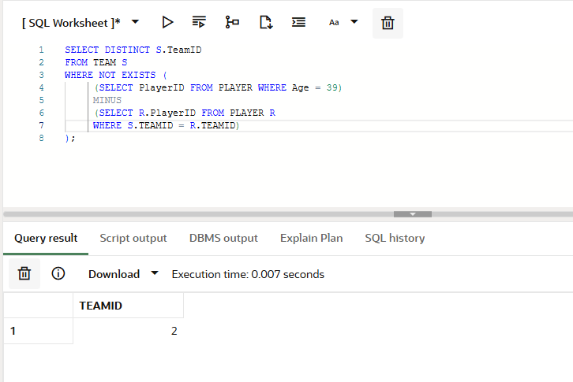

**DERIVED RELATION:**

**Retrieved leagues where the average of points in the LEAGUESTANDING table is greater than 40:**

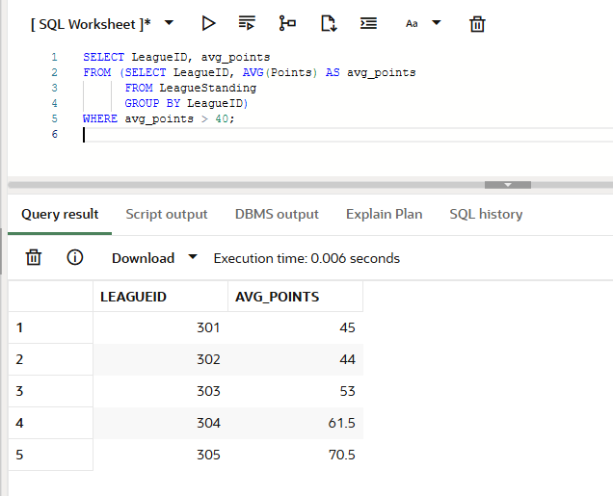

**Find all teams with the maximum points.**

